Australian Fresh Market Full Dashboard findings
NOTE: This report is for learning purposes only
I am welcome for feedback.
- What is our total revenue and gross profit for FY2024?
For the financial year, the Australian Fresh Market generated a total revenue of $1.99M AUD, with a Gross Profit of $1.29M AUD.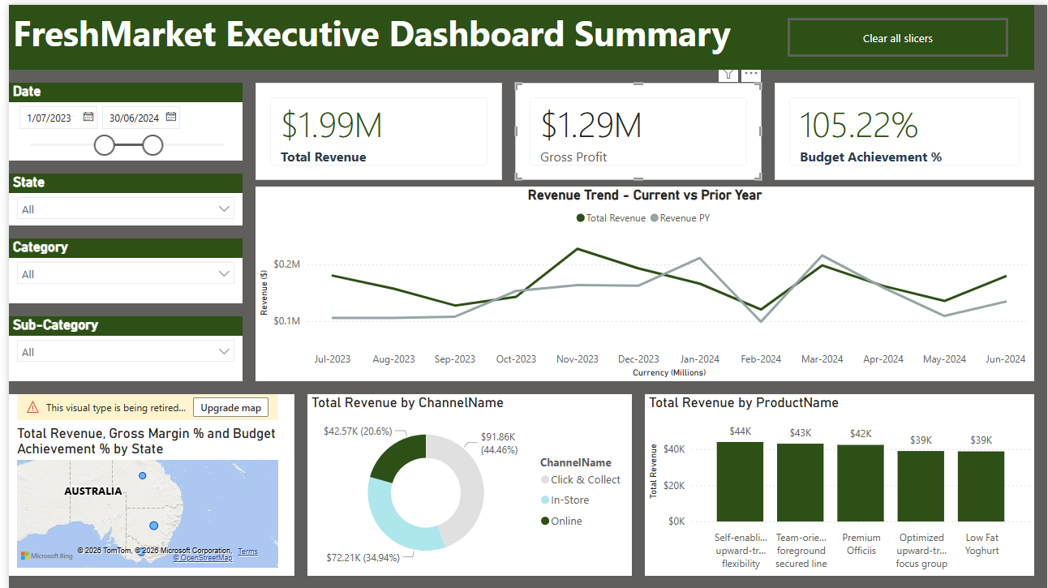
- What is our gross margin % by state, category, and channel?
From 1/1/2022 to 31/12/2025 period,
From 1 January 2022 to 31 December 2025, the Gross Margin % in Victoria is estimated at 64.59%. By channel, 29.2% of sales are In-Store, while 99.42% are via Click & Collect. By category, 99.88% of the gross margin comes from Pantry, 98.86% from Fresh Produce, 99.73% from Meat & Seafood, and 99.78% from Beverages.

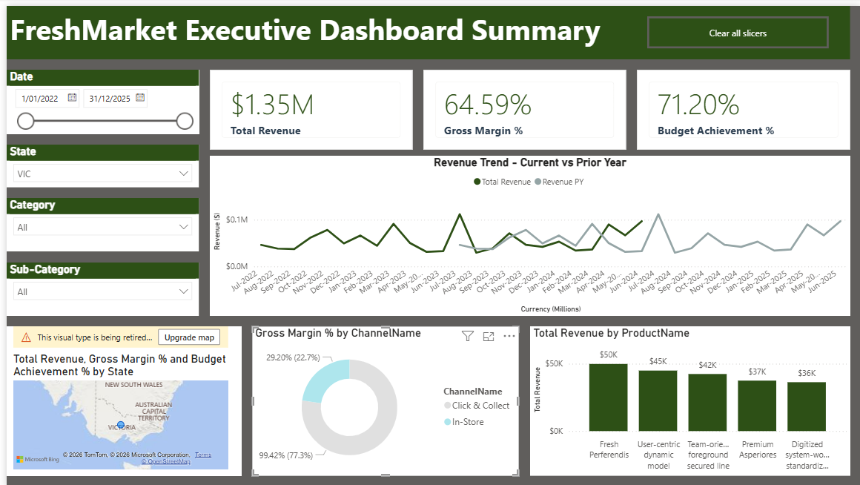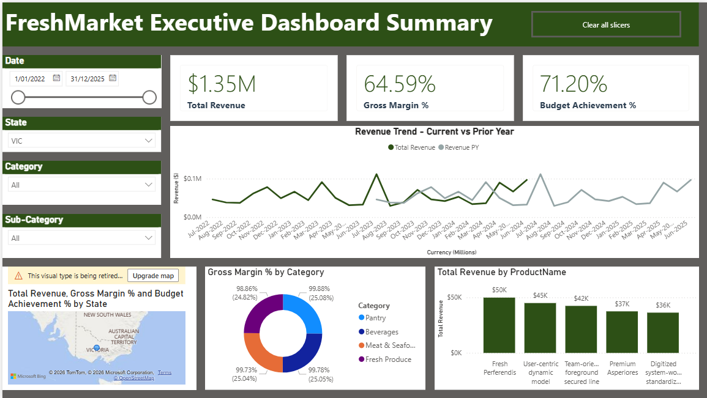

The Gross Margin % in New South Wales is estimated at 62.32%. By channel, 96.68% of sales are through In-Store, 92.94% via Click & Collect, and 95.27% Online. By category, 98.76% of the gross margin comes from Health & Beauty, 79.90% from Dairy & Eggs, and 97.3% from Fresh Produce.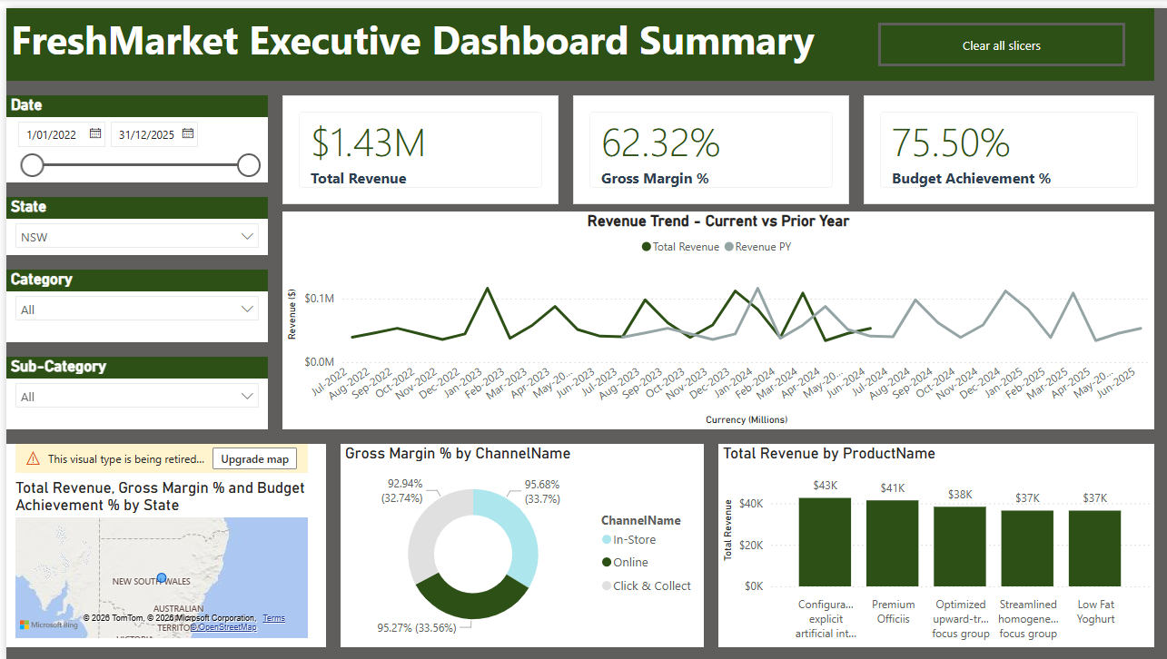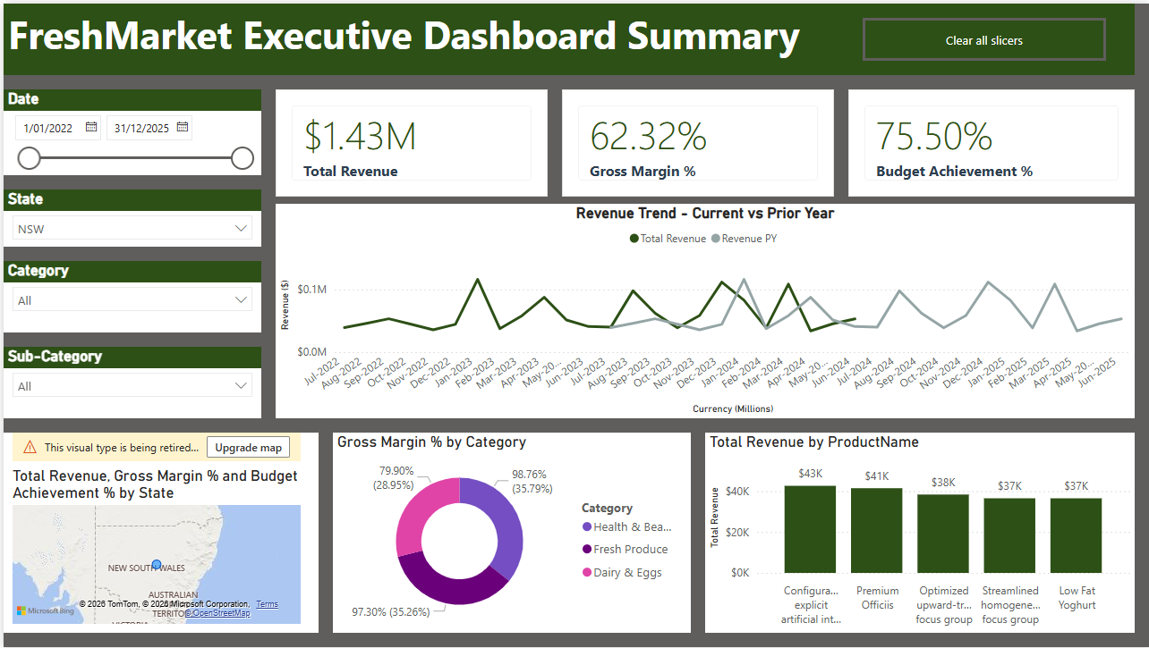

The Gross Margin % in Queensland is estimated at 65.56%. By channel, 99.4% of sales are through In-Store, 99.21% via Click & Collect, and 98.26% Online. By category, 98.04% of sales come from Bakery, 99.72% from Health & Beauty, 99.63% from Fresh Produce, 99.31% from Pantry, and 98.85% from Beverages.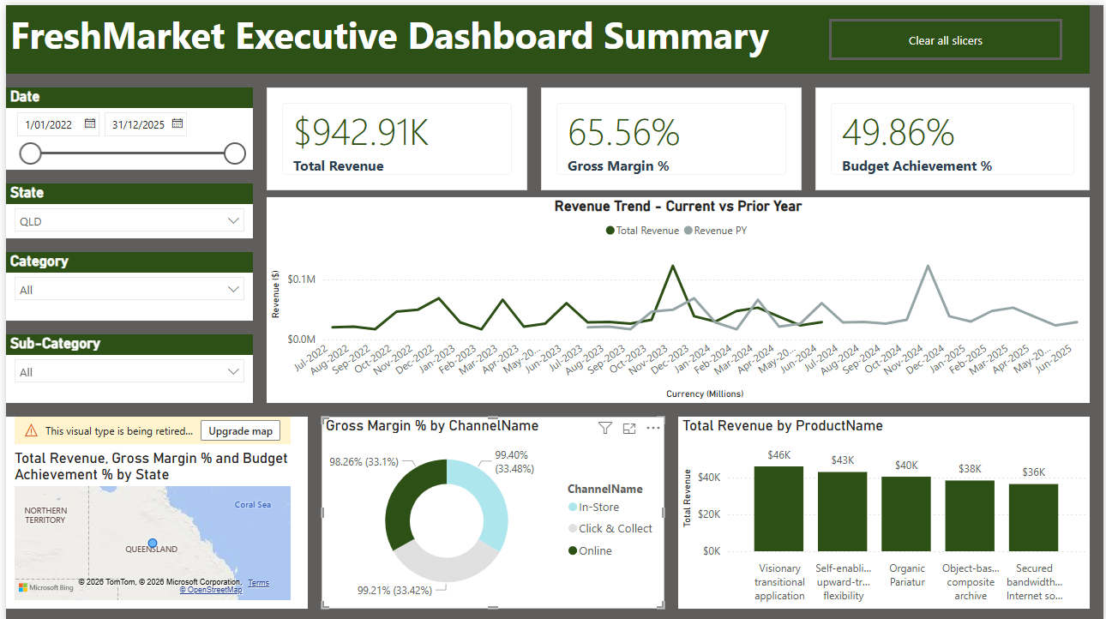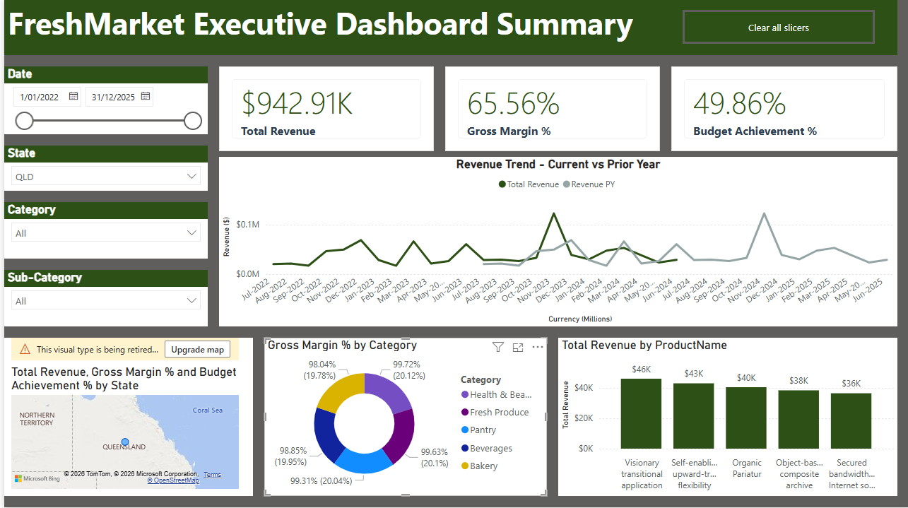

- How do we compare to budget (variance $ and %)?
- We track budget variances in both dollars and percentages using the following DAX measures:
• Variance $ = [Total Revenue] – [Budget Revenue]
• Variance % = DIVIDE([Variance $], [Budget Revenue], BLANK())
- These measures allow us to quickly see how actual performance compares to budget, both in absolute terms and relative to expectations.

- What is our year-to-date (YTD) revenue vs. prior year?
For the Australian Retail Report, the Year-to-Date (YTD) performance for FY2024 is $179,125.29, compared to $134,432.03 in the prior year (PY), reflecting a positive growth trend.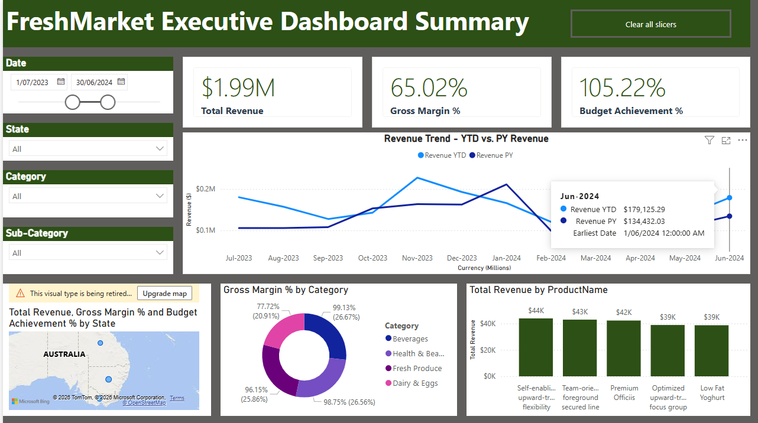
- What is our quarter-to-date (QTD) performance for Q3 FY2024?
For the Australian Retail Report, the QTD performance for Q3 FY24 was $464,968.27, an improvement of 2.47% from the previous quarter, Q2 FY24, which was $476,731.31.

- Which top 5 products drive the most revenue?
For the Australian Retail Report, total revenue by product shows a clear ranking. Fresh Perferendis and Low Fat Yoghurt are the top-performing products, each generating approximately $51K in revenue. These are followed by Low Fat Milk and User-centric dynamic model, both contributing around $49K, while Visionary transitional application ranks lowest among the group at approximately $46K. This descending order highlights which products are driving the most revenue and where performance is comparatively lower.
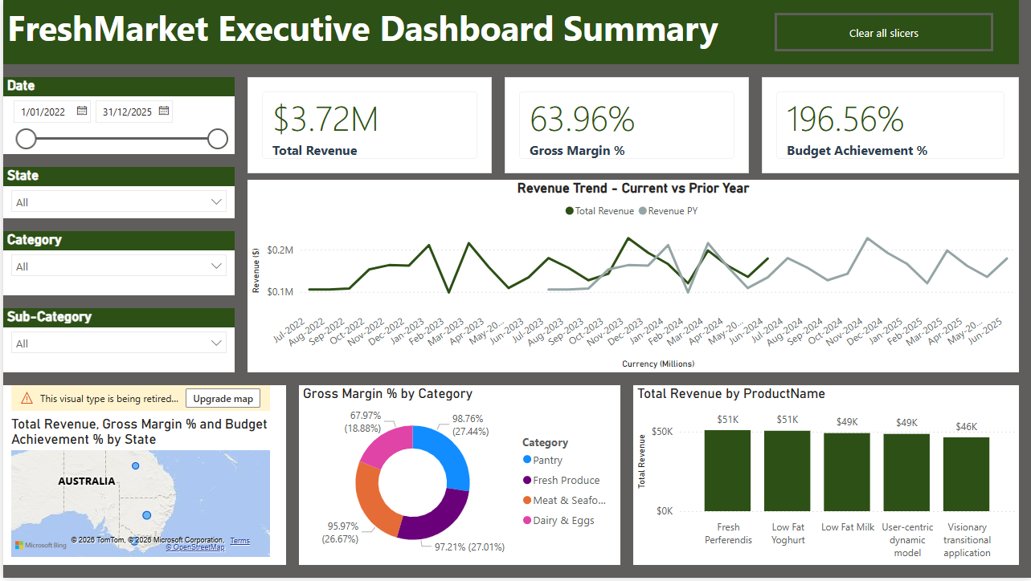

- Which stores underperform (bottom 10 by margin)?

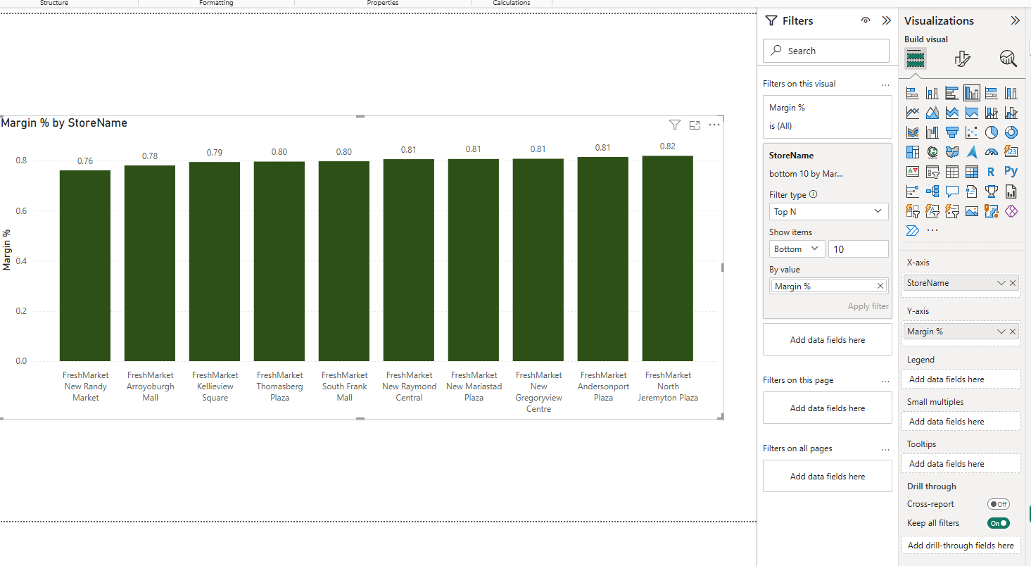
Based on the bottom 10 stores by margin, several locations are underperforming relative to the rest of the network. FreshMarket New Rarby Market has the lowest margin at approximately 76%, followed by FreshMarket Aroyburgh Mall (78%) and FreshMarket Kelliew Square (79%). The remaining underperforming stores — including Thomasberg Plaza, South Frank Mall, New Raymond Central, New Maraisda Plaza, New Gregoryville Centre, Andersonport Plaza, and North Jeremypion Plaza — have margins ranging from around 80% to 82%. While the differences between stores are relatively small, these locations consistently sit at the lower end of margin performance and may benefit from further review to identify cost, pricing, or operational improvement opportunities.
- What is our average order value (AOV) by channel?
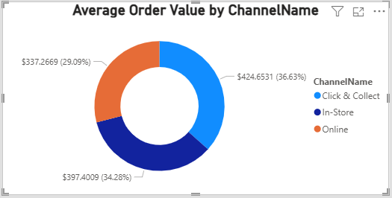
- How does Click & Collect revenue compare to In Store and Online?
From 1 January 2022 to 31 December 2025, across Australia (VIC, NSW, and QLD), Click and Collect is the strongest revenue-generating channel. Although only 46.77% of customers use Click and Collect, this group generates the highest total revenue at $114.80K, compared to $109.33K from In-Store and $21.32K from Online. This indicates that Click and Collect customers contribute more revenue overall than customers in the other channels, highlighting Click and Collect as the most valuable channel during this period.
- What is our 30-day rolling revenue trend?
Create a new Measure:
Revenue 30 Day Rolling =
CALCULATE(
[Total Revenue],
DATESINPERIOD(
DimDate_v2[Date],
MAX(DimDate_v2[Date]),
-30,
DAY
)
)

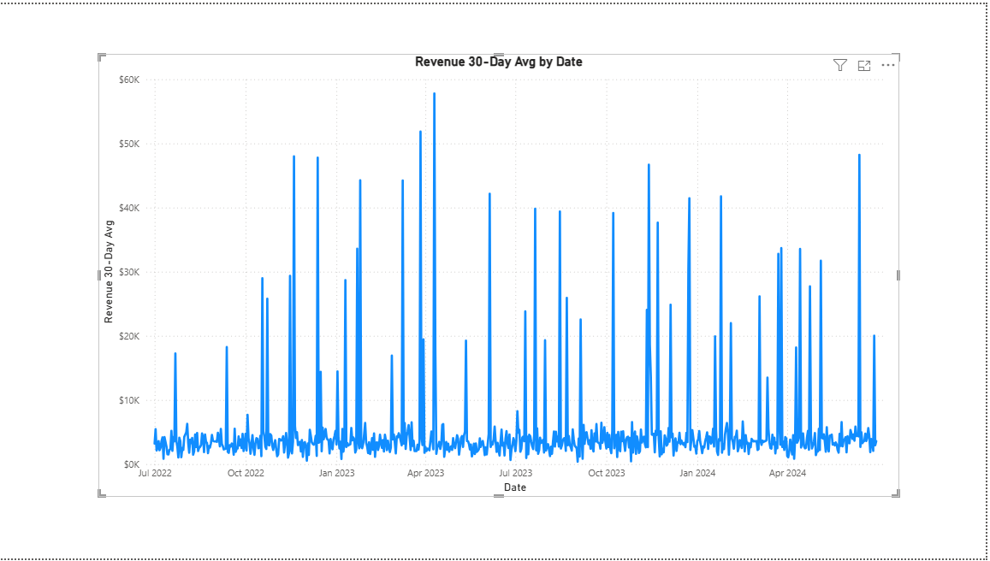
Revenue remains generally stable at a low baseline over time, but it is punctuated by frequent, sharp spikes. These spikes occur irregularly and account for a significant share of total revenue, indicating that performance is largely driven by specific events or campaigns rather than steady, organic growth. Despite using a 30-day average, volatility remains high, showing that short-term revenue surges strongly influence overall results.

